TryHackMe Room Report: Nmap Basic Port Scans
Week: 2
Topic: Network Traffic Analysis and Nmap
Platform: TryHackMe
Date Completed: 26 October 2026
1. Objective
The objective of this exercise was to understand basic Nmap port scanning techniques and learn how to identify open ports and determine which services may be accessible on a target system.
2. Concepts Learned
- TCP port scanning
- Open, closed, and filtered port states
- TCP three-way handshake
- TCP SYN scan
- TCP connect scan
- UDP port scanning
- The purpose of port scanning in network security
3. Tasks Performed
- Studied the fundamentals of Nmap port scanning.
- Learned how to identify open ports on a target system.
- Reviewed the differences between TCP SYN scans and TCP connect scans.
- Learned how TCP connection establishment relates to port scanning.
- Reviewed how firewall rules can affect scan results.
- Studied how port scanning helps security professionals identify exposed network services.
4. Commands Used
Command 1: Basic port scan
nmap <target-ip>
Explanation: Scans commonly checked TCP ports on the target and reports their observed states.
Command 2: TCP SYN scan
nmap -sS <target-ip>
Explanation: Sends TCP SYN probes to examine port states without completing the normal TCP three-way handshake for each port.
Command 3: TCP connect scan
nmap -sT <target-ip>
Explanation: Uses the operating system's connect function to establish TCP connections to target ports.
Command 4: UDP scan
nmap -sU <target-ip>
Explanation: Checks UDP ports to identify potentially available UDP services. UDP scans may take longer and can produce inconclusive results.
Command 5: Scan specific ports
nmap -p 22,80,443 <target-ip>
Explanation: Scans ports 22, 80, and 443, commonly associated with SSH, HTTP, and HTTPS.
5. Findings and Observations
- Port scanning helps identify network services accessible on a target.
- An open port indicates that a service is accepting connections or responding as open to the scan.
- A closed port indicates that the target is reachable but no service is listening on that port.
- A filtered port indicates that filtering or other network conditions prevent Nmap from determining the port state clearly.
- TCP SYN scans and TCP connect scans use different methods to test TCP ports.
- UDP scanning can be slower because UDP services may not respond to probes.
- SOC Analysts can use knowledge of port scans to investigate reconnaissance activity and identify unexpected network exposure.
Actual scan results: Specific ports and services were not recorded in the information available for this report.
6. Screenshot
Insert the single screenshot showing the completed TryHackMe room and its completion status.
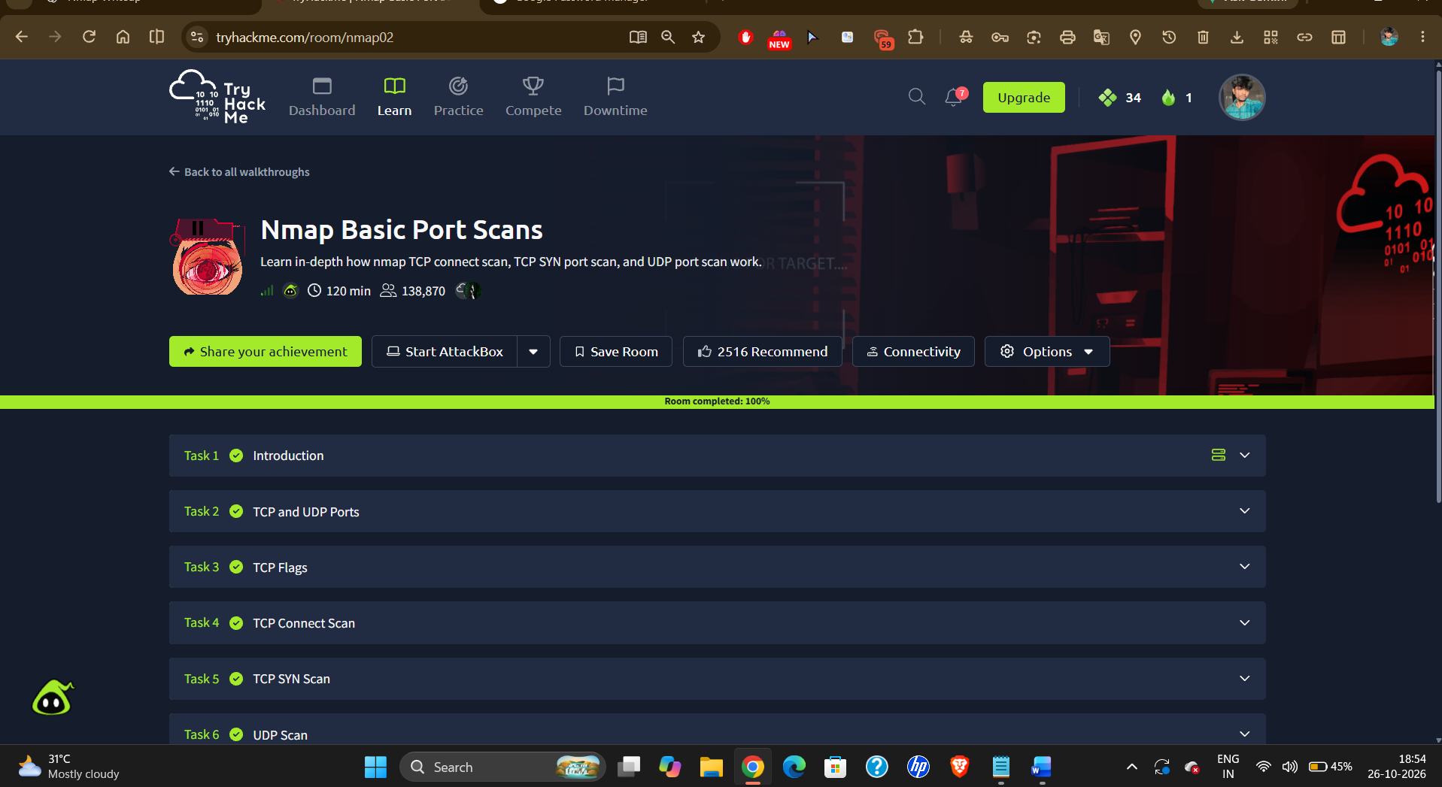
Caption: Successfully completed the Nmap Basic Port Scans exercise and reviewed basic port scanning techniques.
7. Challenges Faced
The main learning challenge was understanding the differences between TCP SYN scans, TCP connect scans, and UDP scans, along with interpreting open, closed, and filtered port states.
8. Conclusion
This exercise helped me understand basic Nmap port scanning techniques and how they are used to identify accessible ports and services. These skills are useful for network security assessments, understanding network exposure, and investigating suspicious scanning activity as a SOC Analyst.

